1. **Scatter plot of the Occurrence of a two words in articles**

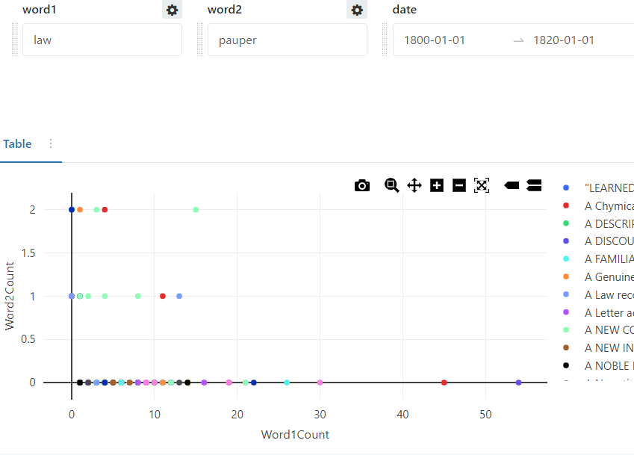

Query:

SELECT

*,

SIZE(regexp_extract_all(lower(text), concat("(\\W)", {{word1}}, "(\\W)"), 0)) as Word1Count,

SIZE(regexp_extract_all(lower(text), concat("(\\W)", {{word2}}, "(\\W)"), 0)) as Word2Count

FROM

default.century1_avro

WHERE

SIZE(regexp_extract_all(lower(text), concat("(\\W)", {{word1}}, "(\\W)"), 0)) + SIZE(regexp_extract_all(lower(text), concat("(\\W)", {{word2}}, "(\\W)"), 0)) > 0

AND (

to_date(cast(NumericPubDate as string), 'yyyyMMdd') BETWEEN DATE '{{ date.start}}'

AND DATE '{{ date.end }}'

)

AND find_in_set(TypeOfArticle,"{{Type of Article}}") > 0

1. **Drop-down query with “SELECT ALL” option**

*When using category to filter, use inclusion (OR {{param}} = Select All)*

SELECT

TypeOfArticle

FROM

(

Select Distinct

TypeOfArticle

From

default.century1_avro

UNION ALL

SELECT

'-- All Categories --' AS TypeOfArticle

)

ORDER BY

TypeOfArticle

1. **Counter visualization displaying percentage of a Title-Article relationship**

